Bug ID: OPEN_CART_BUG_1
Title: Registration confirmation email not received after successful account creation
Module: User Registration
Severity: Low
Priority: Low
Defect Type: Environment / Configuration
Pre-condition
User is on the Register Account page.
Steps to Reproduce
- Open the application.
- Click My Account → Register.
- Fill all mandatory fields.
- Accept Privacy Policy.
- Click Continue.
- Check the registered email inbox.
Expected Result
User account should be created and a confirmation email (“Thank you for registering”) should be received.
Actual Result
Account is successfully created but no confirmation email is received.
Note
Application is running on localhost without SMTP/mail configuration, therefore email service is not configured in the test environment.
Status
Not a functional defect — Environment limitation.

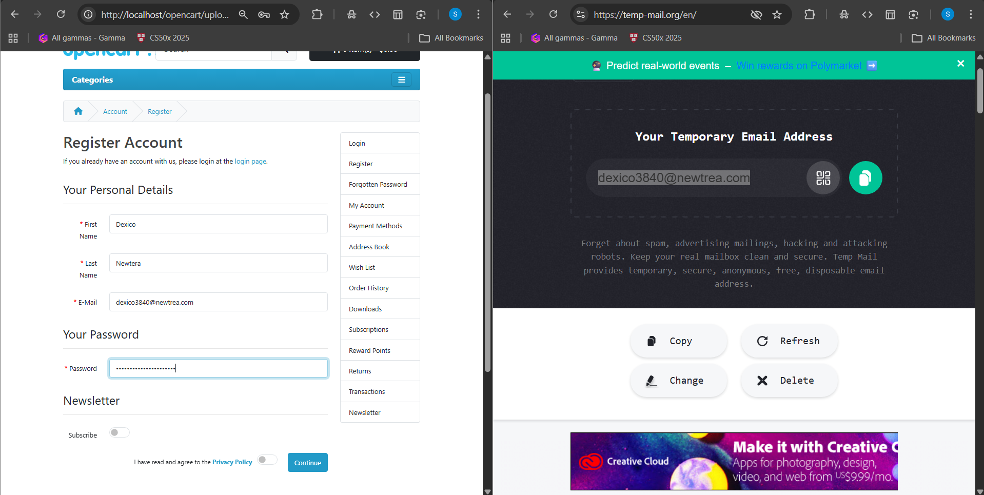

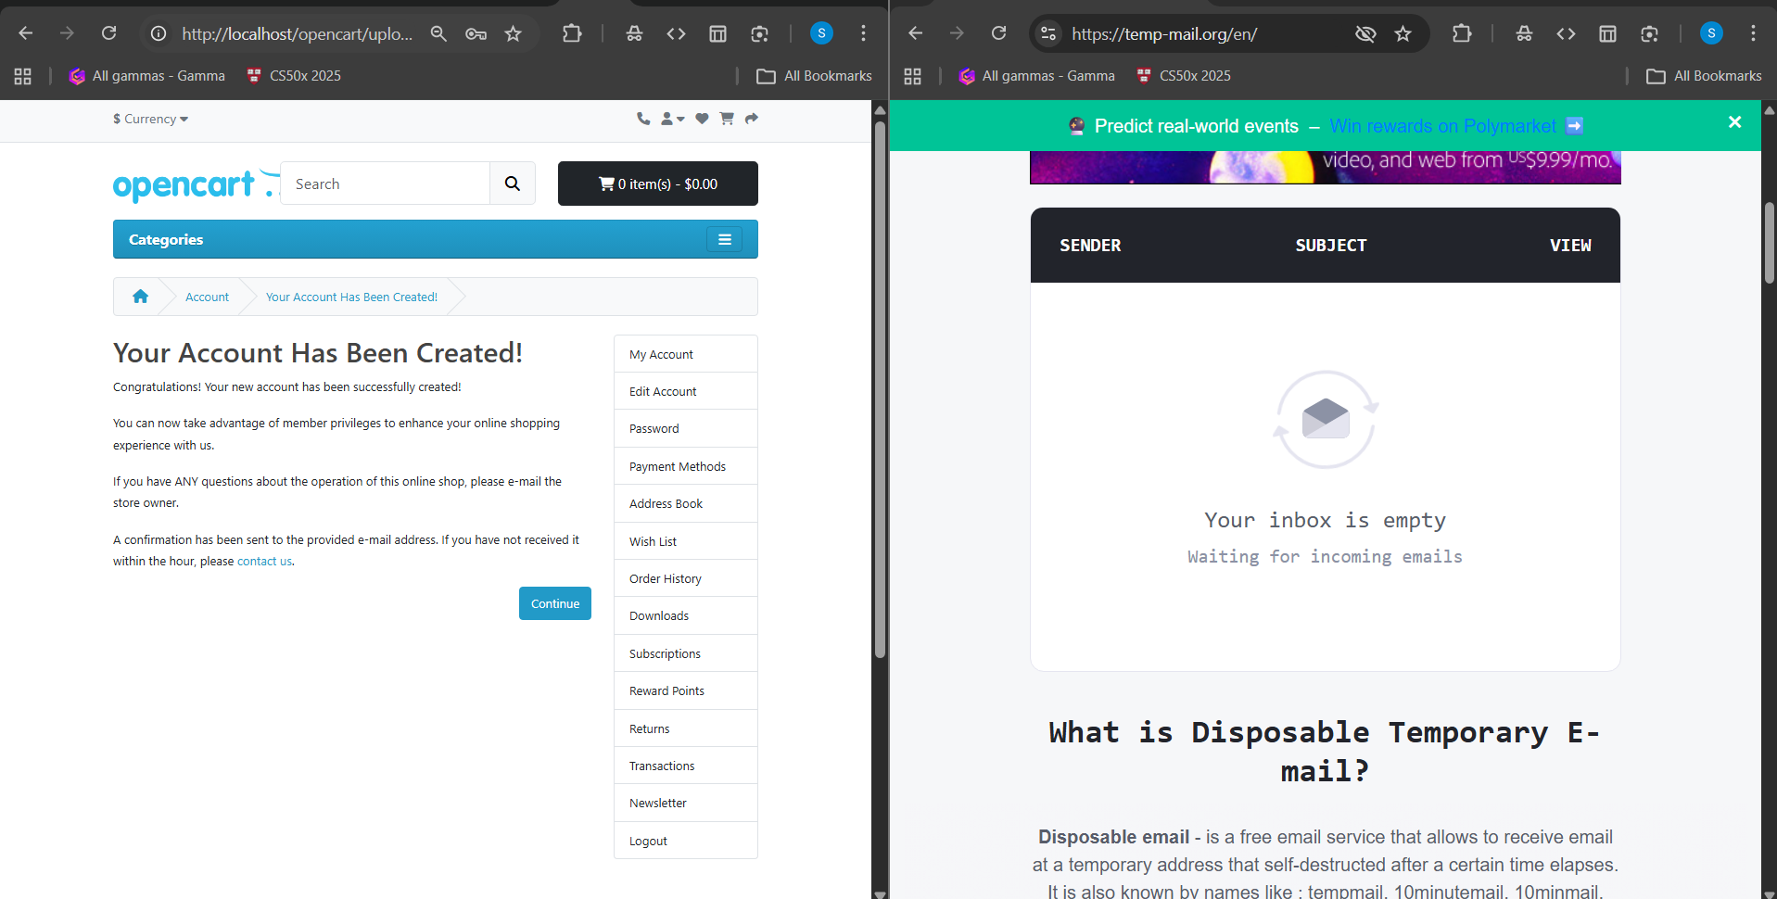

Bug ID: OPEN_CART_BUG_2
Title: Privacy Policy checkbox not marked as mandatory (*) on Register page
Module: Registration Page
Severity: Minor
Priority: Low
Defect Type: UI / Usability
Steps to Reproduce
- Open Register Account page.
- Observe all mandatory fields.
Expected Result
Privacy Policy checkbox should be marked with a red asterisk (*) indicating it is mandatory.
Actual Result
Checkbox is mandatory but no visual indicator (*) is displayed.
Impact
Users may not understand why the form cannot be submitted.
Status
Valid UI usability issue.

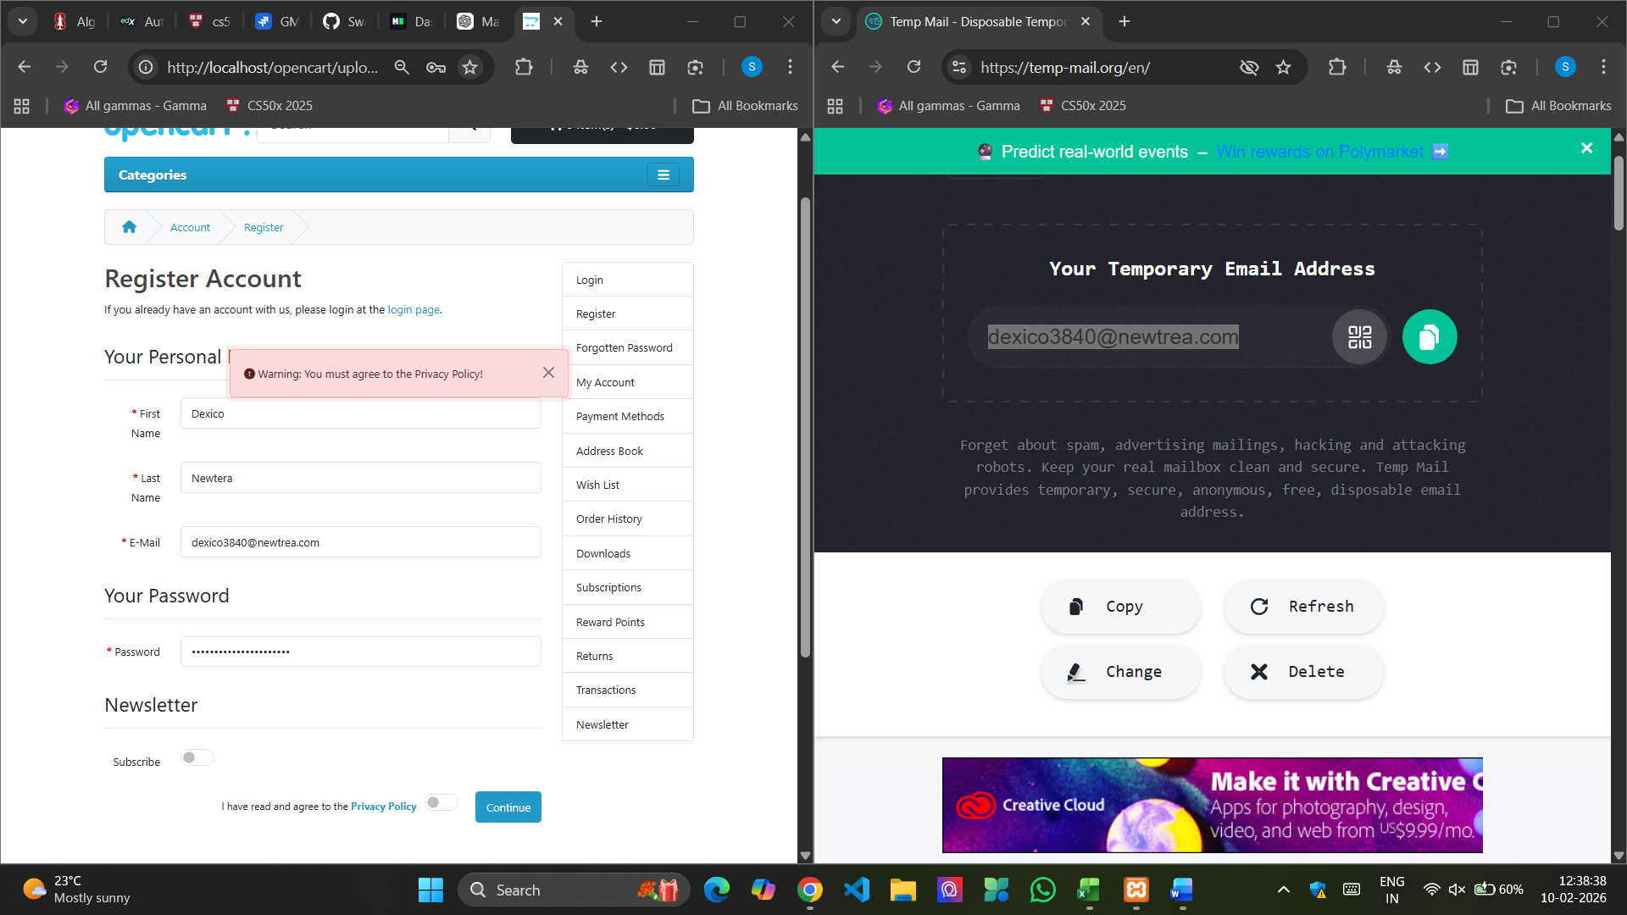

Bug ID: OPEN_CART_BUG_3
Title: Registration accepts weak password without complexity validation
Module: User Registration
Severity: Major
Priority: High
Defect Type: Security / Validation
Steps to Reproduce
- Open Register page.
- Enter valid details.
- Enter password: 123456
- Accept Privacy Policy.
- Click Continue.
Expected Result
System should reject weak passwords and display message requiring:
- minimum 8 characters
- uppercase
- lowercase
- number
- special character
Actual Result
Account is created successfully using a weak password “123456”.
Impact
Creates serious security risk — accounts easily compromised.
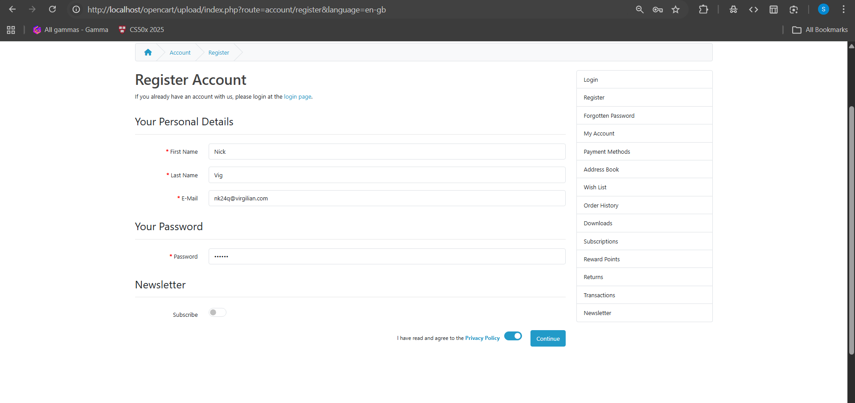

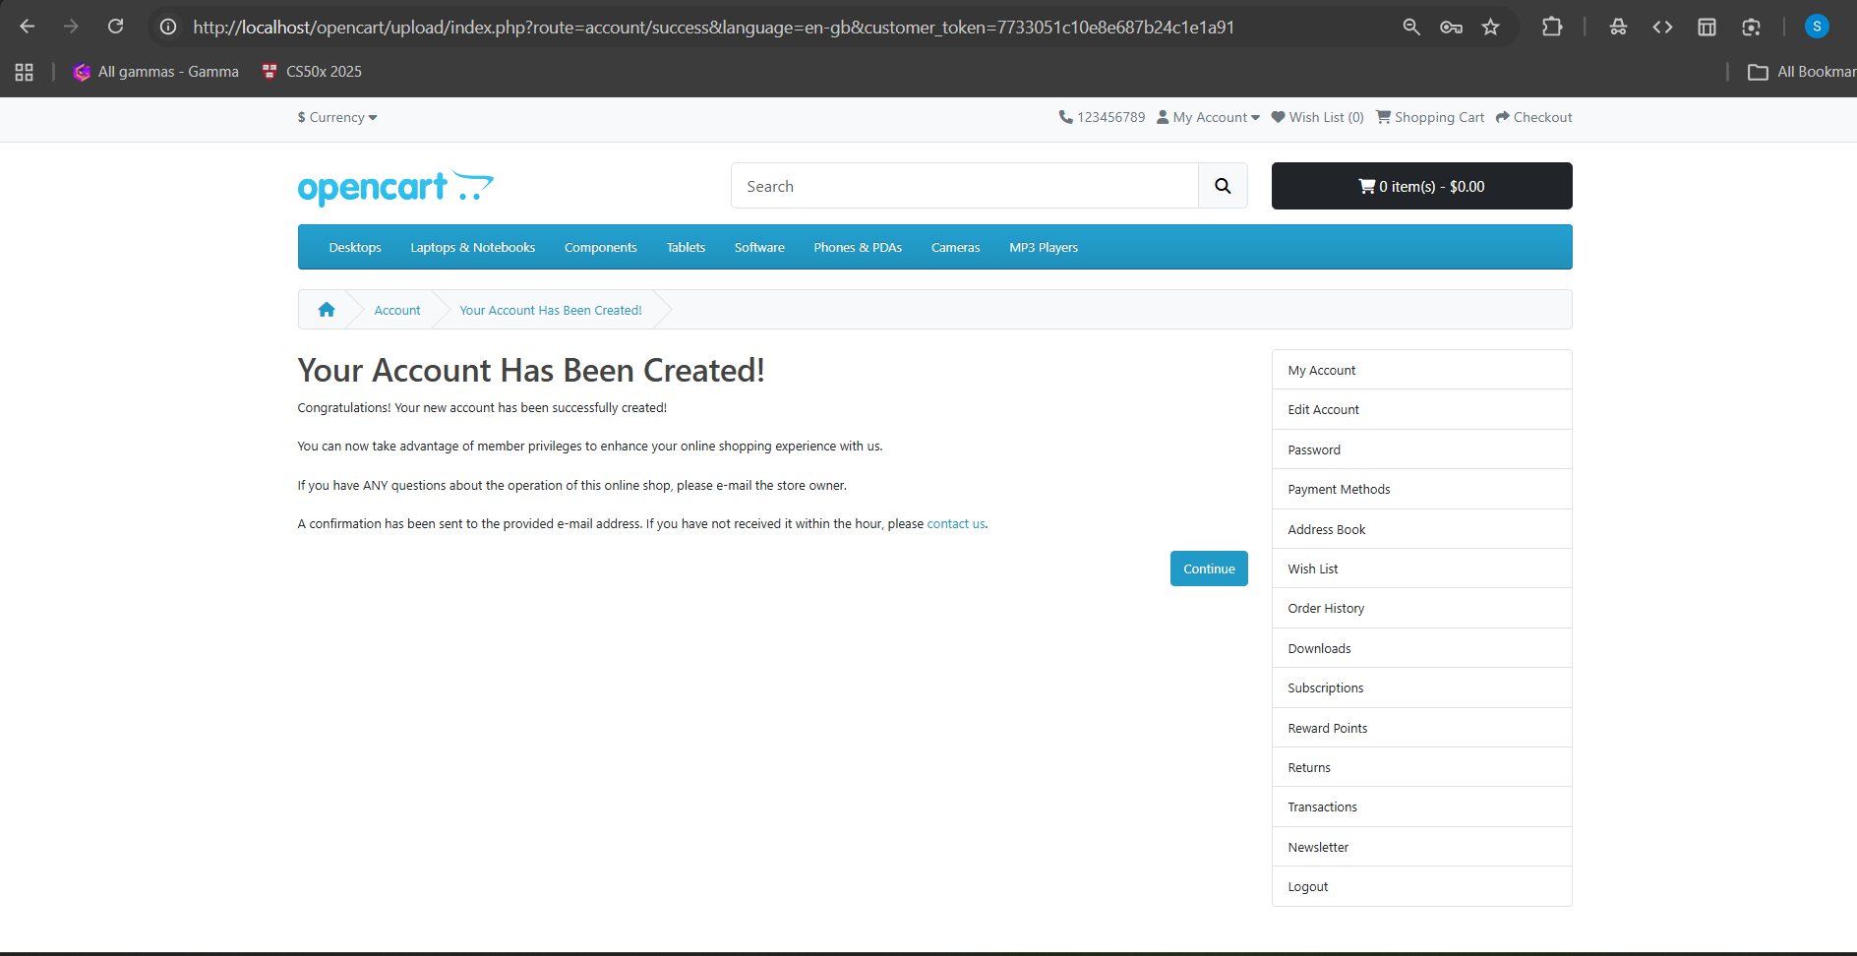

Bug ID: OPEN_CART_BUG_4
Title: System allows leading and trailing whitespace in First Name field before submission
Module: Registration Page
Type: Validation / Usability Observation
Severity: Low
Priority: Low
Precondition:
User is on Account Registration page
Steps to Reproduce:
- Open OpenCart Register page
- Enter First Name as: Swayam
- Fill remaining mandatory fields
- Click Continue
Actual Result:
System accepts the input and creates account. Spaces are trimmed automatically after submission.
Expected Result:
System should prevent leading and trailing spaces or auto trim the field on client side before form submission and inform the user.
Impact:
May confuse users and causes unnecessary server-side processing.
Status: Observation / Enhancement Suggestion
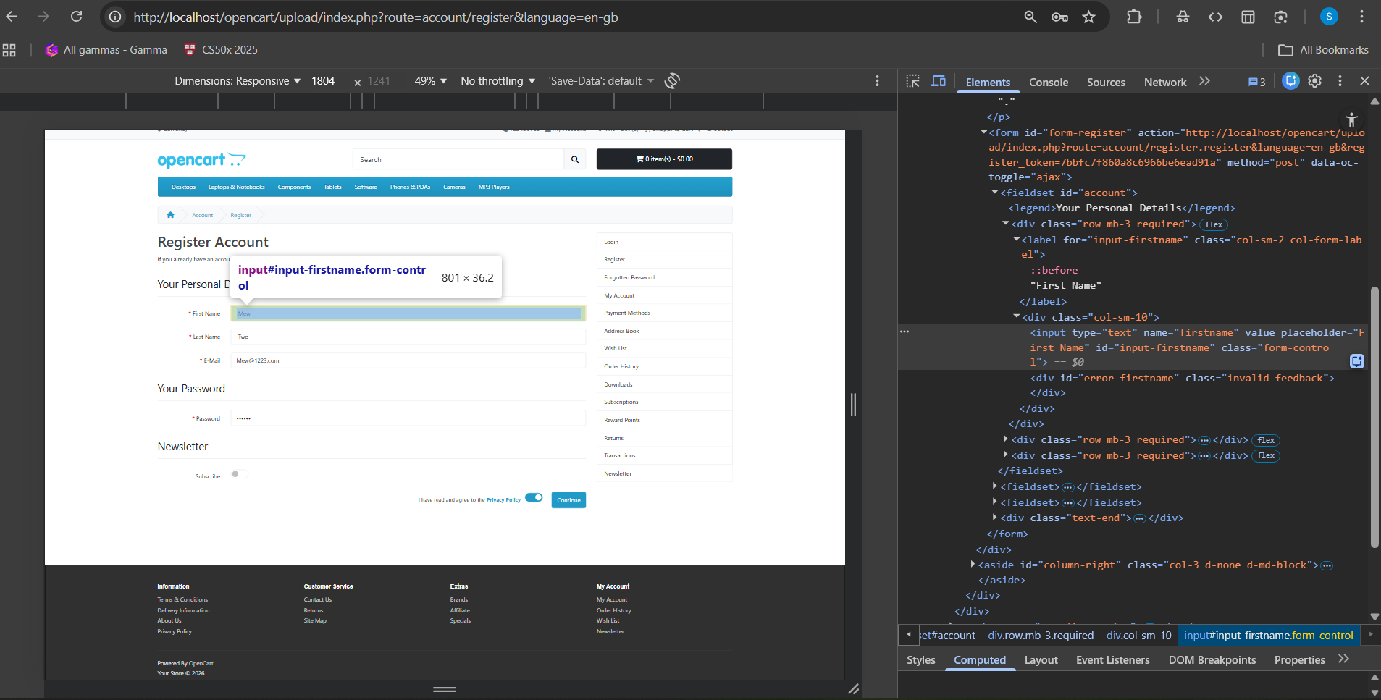

Bug ID: OPEN_CART_BUG_5
Title: “Search in subcategories” checkbox is not reachable using keyboard (TAB navigation)
Module: Product Search / Advanced Search Page
Environment:
- Application: OpenCart (User Frontend)
- Browser: Chrome (tested on localhost)
- URL: = http://localhost/opencart/upload/index.php?route=product/search&language=en-gb&search=%20%20%20%20%20%20

Pre-Condition
User is on the Advanced Product Search page.

Steps to Reproduce
- Open the application homepage.
- Click the Search icon without entering any text.
- The Advanced Search page opens.
- Do NOT use the mouse.
- Press the TAB key repeatedly to navigate through the form fields.

Expected Result
Keyboard focus should sequentially move through all interactive controls, including:
- Search in product descriptions (checkbox)
- Category dropdown
- Search in subcategories (checkbox)
User should be able to select the “Search in subcategories” checkbox using the SPACEBAR.

Actual Result
Keyboard focus moves from:
Search in product descriptions → Category dropdown → Search button
The “Search in subcategories” checkbox is skipped and cannot be selected using keyboard navigation.

Impact
Keyboard-only users and users relying on assistive technologies (accessibility users) cannot enable subcategory search.
The feature becomes unusable without a mouse and violates basic usability and accessibility standards.

Severity
Minor (Usability / Accessibility issue)
Priority
Medium (P2)

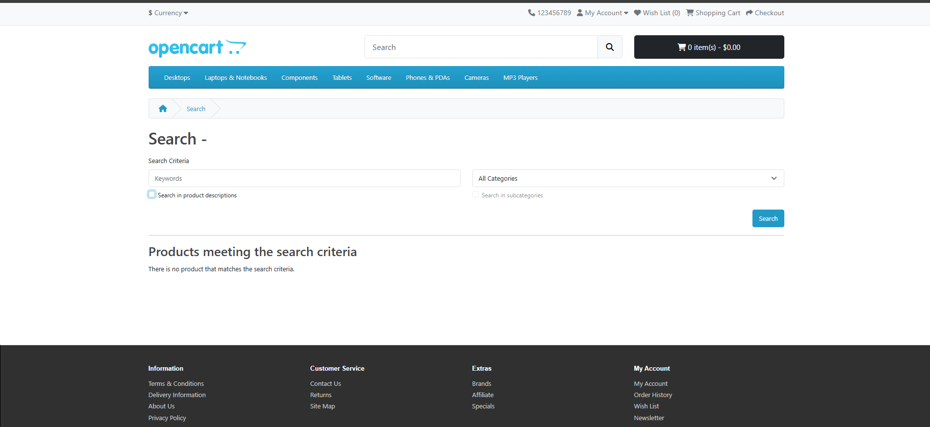

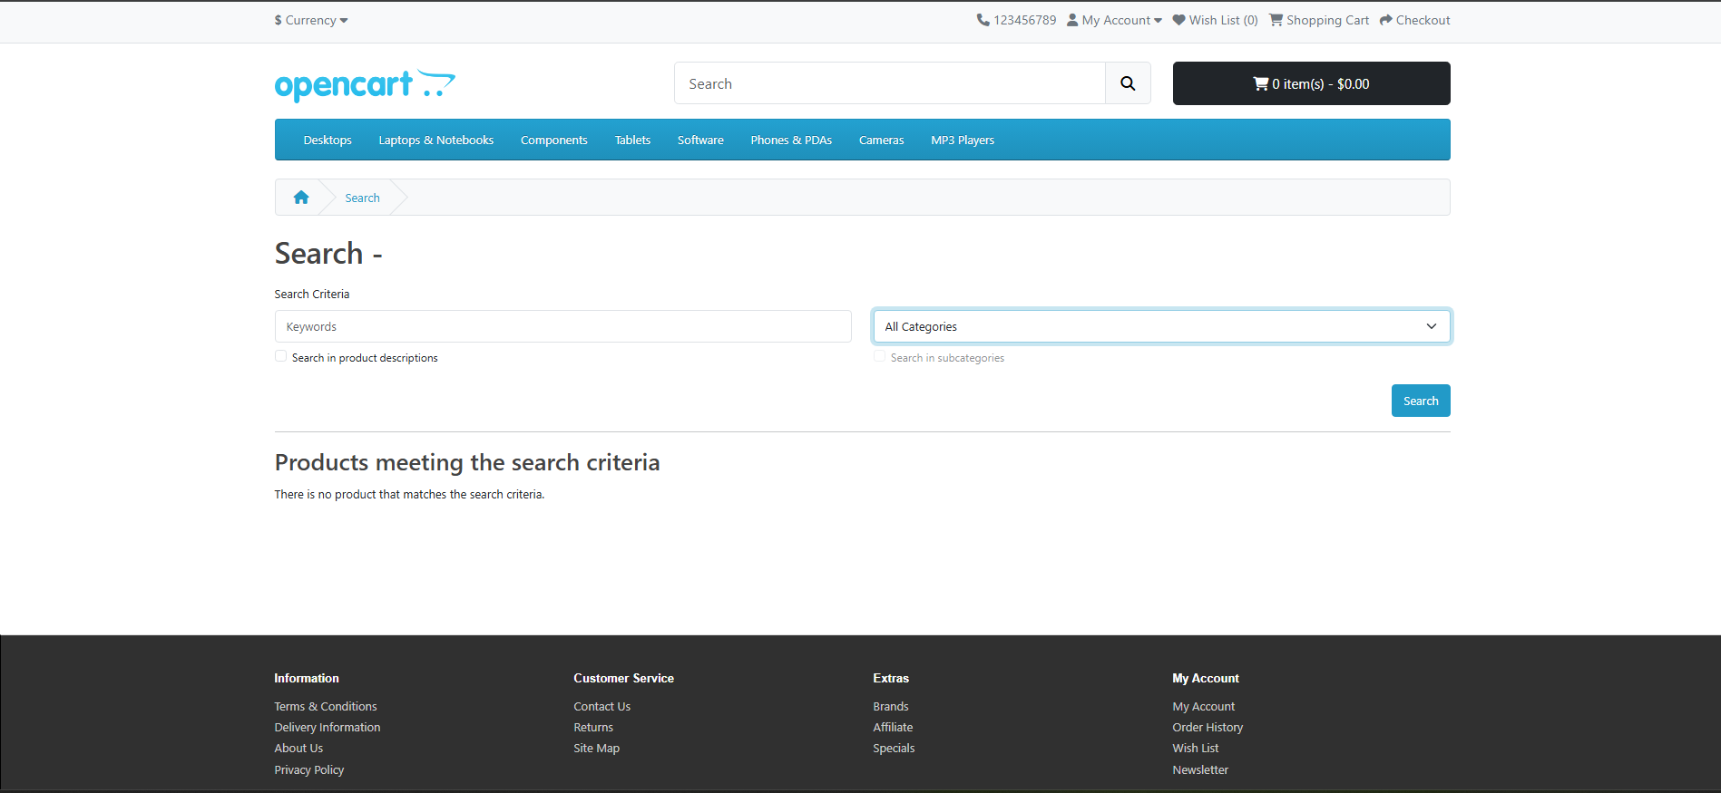

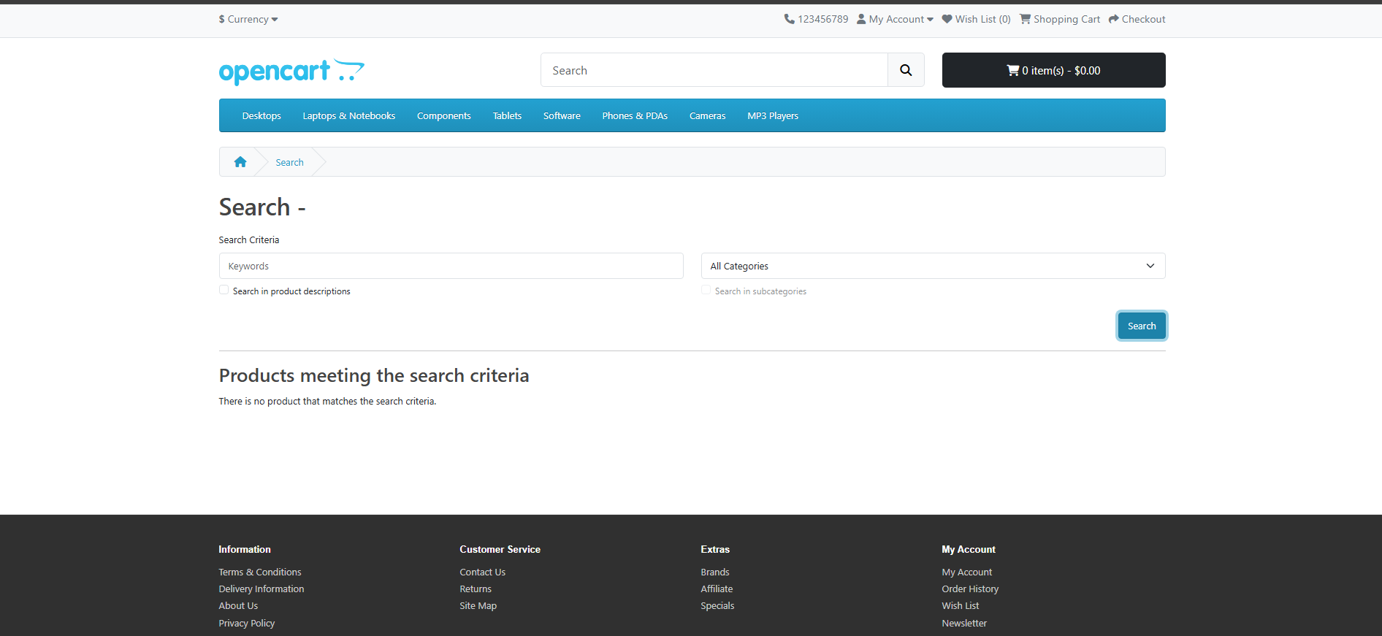

Bug ID: OPEN_CART_BUG_6
Title: Product can be added to cart with quantity value 0
Module: Shopping Cart / Product Page
Severity: Major
Priority: High
Defect Type: Functional / Business Logic Validation
Steps to Reproduce
- Open the application.
- Search for MacBook.
- Open the product page.
- Clear default quantity (1).
- Enter 0 in Qty field.
- Click Add to Cart.
Expected Result
System should display validation message:
“Quantity must be greater than 0”
Product should NOT be added to cart.
Actual Result
System displays success message “Product added to cart”.
Impact
Cart may contain invalid order quantity and cause incorrect order processing or billing issues.

